**CEM 252 Recitation week 6**: **Part I** Timekeeper

Evaluating Information from

student responses to homework and exams Recorder

Reporter

For these questions

1. Construct a correct answer
2. Use it to develop a grading key (out of 5 points) for each question. Make sure you specify which parts of your answer are necessary



**Question 1.** Explain why, in the H-1 NMR spectrum of this ester, the CH2 appears downfield of the CH3 to which it is attached.

**Question 2: Which molecule has the most acidic hydrogen? Explain your choice.**

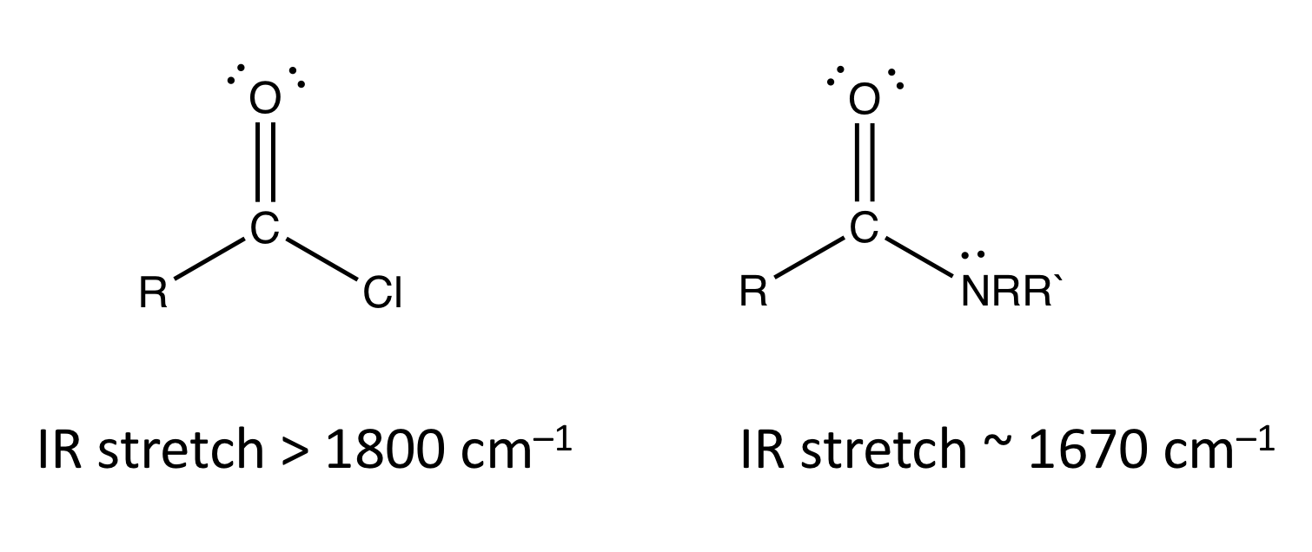**Question 3:** Explain why the carbonyl peak of an amide appears at a different wavenumber than that of an acid chloride.

**CEM 252 Recitation week 6**: **Part Part 2:**

**Here are the answer keys (written by us) to the questions. Use them to revise your answers and answer keys.**

**Question 1. Answer key:**

The NMR signal is a measure of the energy that is absorbed or released when nuclei “flip” from one spin state to another. The energy gap between spin states depends on both the applied (external) magnetic field, and the resulting induced magnetic field generated by the electron density around the nucleus. This induced field opposes the external field, and shields the nucleus from the external field. The lower the electron density around the nucleus, the weaker the induced field, and therefore the nucleus “feels” more of the external field. Thus an electron deficient nucleus will spin flip at a lower field than an electron rich nucleus.

The oxygen attached to the CH2 group is attracting electrons because oxygen is so electronegative relative to carbon. This reduces the electron density around the carbon (it is deshielded), and therefore less energy (than for the CH3) is required to make the nucleus flip.

**Question 2: Answer Key**

Phenol is most acidic. There are two criteria that determine whether a particular hydrogen is acidic. 1) the H should be bonded to an electronegative atom so that the bond is polarized, with a partial positive on the H, which will make it attract a base. 2) the resulting anion should be stable.

Both methanol and phenol meet criterion 1). Methane does not, because the C-H bonds are non-polar. The anion resulting from deprotonation of phenol can be delocalized by resonance into the ring. This “spreading out” or delocalizing the charge makes it more stable because there are fewer electrons in the same place repelling each other. Methoxide (i.e. deprotonated methanol) l has the negative charge localized the oxygen and therefore its anion is less stable, and methanol is less acidic.

**Question 3: Answer key:**

Infrared spectroscopy measures the energy that it takes to make a bond vibrate. The stronger the bond, the more energy it takes to promote that bond to a higher vibrational energy state, because more energy is needed to overcome the attractions between the two nuclei and the electrons in the bond. The amide carbonyl peak appears at a lower wavenumber than the acid chloride carbonyl peak, indicating that less energy is needed to stretch the double bond of the amide carbonyl. This is because the carbonyl double bond has more single bond character in the amide than in the acid chloride. The lone pair on the amide nitrogen interacts with the carbonyl carbon to form a species in which there is less C=O character and more C=N character than indicated by a simple Lewis structure.

1. Now grade each student response a score (out of 5). You should indicate why points were removed.
2. Point out incorrect statements and material in the answer that is not relevant.

**Q 1: Student Responses**

*“It appears downfield because the CH2 is bonded to the Oxygen so the electronegativity is high.”*

*“The CH2 group appears downfield due to the electronegative O that it is attached to. The electronegativity of the O pulls the electrons from the CH2 towards itself, therefore deshielding the CH2 molecule. Because of this deshielding, the CH2 would appear more downfield than the other molecules.”*

*“The CH2 is connected to a very electronegative oxygen. The oxygen negative partial charge is pulling on the partial positive charges of the hydrogens, pulling them more down the spectrum.”*

**Student Responses: Q 2**

*“Methanol, because the hydrogen is attached to an oxygen which is electronegative. The O-H bond is highly polarized, it's ready to be donated to another species.”*

*“Phenol is the most acidic, phenol has multiple resonance structures that simultaneously exist allowing for a more even distribution of the negative charge, and since it can better stabilize the negative charge it is the strongest acid.”*

*“Phenol, because of resonance and induction, it stabilizes the electrons more making it a better acid”*

**Student responses: Q3**

*“The lone pair on the N can more easily donate electrons to other atoms making it more stable where as the chlorine just stays where it is. its also easier to vibrate a single bond than a double bond, so stronger double bonds appear more downstream”*

*“There wouid be different peaks on the IR spectrum because there are different elements at different wavelengths when run through an IR spec. There are more bonds in the amide making it less reactive so therefore a smaller wavelength. Also the Cl on the acid chloride has more electron lone pairs and is more likely to leave as a leaving group.”*

*“A higher IR spectra indicates that a bond is harder to stretch. This means there is a stronger bond in the acid chloride than in the amide. The reason for this can be seen when we observe the amide (see picture). In the amide, the nitrogen is able to donate its electron pair to its bond with carbon, making the O negatively charged. This resonance causes the double bond between C and O to behave less like a double bond and more like a single bond. Thus, it is easier to stretch. Acid chloride, however, is a polarized molecule because the chloride is very electronegative. This makes the double bond between C and O even stronger, making it harder to stretch.”*